EXERCISE-1
Control Structures
-- Customer Table
CREATE TABLE Customers (
CustomerID NUMBER PRIMARY KEY,
Name VARCHAR2(50),
Age NUMBER,
Balance NUMBER,
IsVIP VARCHAR2(5)
);
-- Loan Table
CREATE TABLE Loans (
LoanID NUMBER PRIMARY KEY,
CustomerID NUMBER,
InterestRate NUMBER,
DueDate DATE,
FOREIGN KEY(CustomerID) REFERENCES Customers(CustomerID)
);
INSERT INTO Customers VALUES (1,'Ramesh',65,15000,'FALSE');
INSERT INTO Customers VALUES (2,'Suresh',45,8000,'FALSE');
INSERT INTO Customers VALUES (3,'Mahesh',70,25000,'FALSE');
INSERT INTO Customers VALUES (4,'Anita',30,12000,'FALSE');

INSERT INTO Loans VALUES (101,1,10,SYSDATE+20);
INSERT INTO Loans VALUES (102,2,12,SYSDATE+45);
INSERT INTO Loans VALUES (103,3,11,SYSDATE+10);
INSERT INTO Loans VALUES (104,4,9,SYSDATE+25);

COMMIT;
SELECT * FROM Customers;

SELECT * FROM Loans;
DECLARE
BEGIN
FOR cust IN (
SELECT CustomerID
FROM Customers
WHERE Age > 60
)
LOOP
UPDATE Loans
SET InterestRate = InterestRate - 1
WHERE CustomerID = cust.CustomerID;
END LOOP;

COMMIT;

DBMS_OUTPUT.PUT_LINE('Interest rates updated');
END;
/
SELECT * FROM Loans;
DECLARE
BEGIN
FOR cust IN (
SELECT CustomerID
FROM Customers
WHERE Balance > 10000
)
LOOP
UPDATE Customers
SET IsVIP = 'TRUE'
WHERE CustomerID = cust.CustomerID;
END LOOP;

COMMIT;

DBMS_OUTPUT.PUT_LINE('VIP status updated');
END;
/

SELECT * FROM Customers;
SET SERVEROUTPUT ON;

DECLARE
BEGIN
FOR loan_rec IN (
SELECT c.Name,
l.DueDate
FROM Customers c
JOIN Loans l
ON c.CustomerID = l.CustomerID
WHERE l.DueDate BETWEEN SYSDATE AND SYSDATE + 30
)
LOOP
DBMS_OUTPUT.PUT_LINE(
'Reminder: Loan due for '
|| loan_rec.Name
|| ' on '
|| TO_CHAR(loan_rec.DueDate,'DD-MON-YYYY')
);
END LOOP;
END;
/

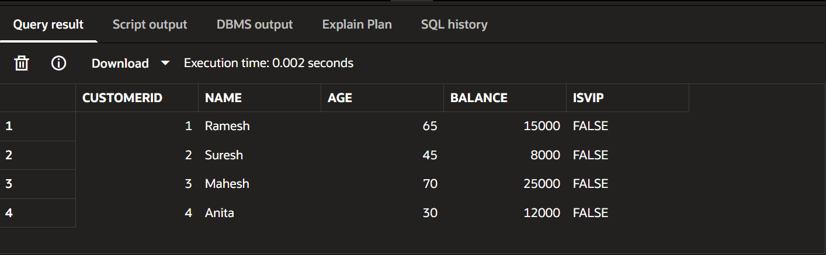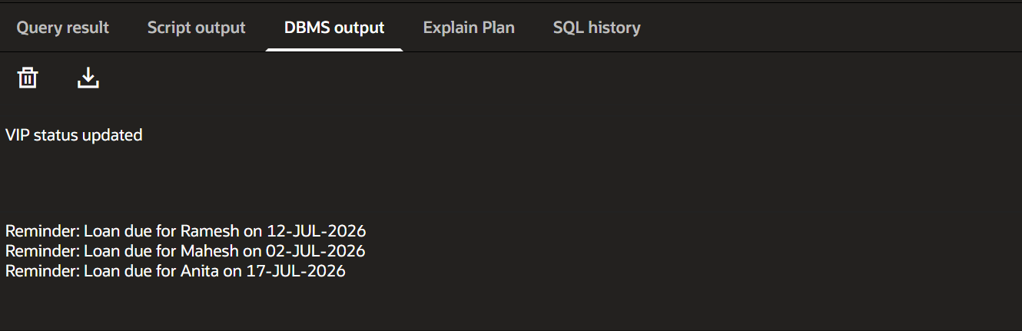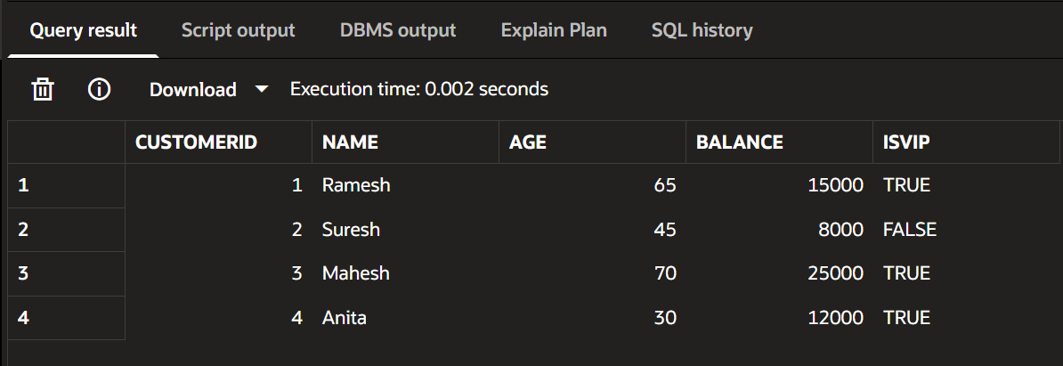

EXERCISE-2
ERROR HANDLING

-- Accounts Table
CREATE TABLE Accounts (
AccountID NUMBER PRIMARY KEY,
CustomerName VARCHAR2(50),
Balance NUMBER
);

-- Employees Table
CREATE TABLE Employees (
EmployeeID NUMBER PRIMARY KEY,
EmployeeName VARCHAR2(50),
Salary NUMBER
);

-- Customers Table
CREATE TABLE Customers (
CustomerID NUMBER PRIMARY KEY,
CustomerName VARCHAR2(50),
Age NUMBER
);
INSERT INTO Accounts VALUES (101,'Ramesh',20000);
INSERT INTO Accounts VALUES (102,'Suresh',5000);

INSERT INTO Employees VALUES (1,'Anil',40000);
INSERT INTO Employees VALUES (2,'Sunita',50000);

INSERT INTO Customers VALUES (1,'Raj',25);
INSERT INTO Customers VALUES (2,'Priya',30);

COMMIT;
SELECT * FROM Accounts;

SELECT * FROM Employees;

SELECT * FROM Customers;
CREATE OR REPLACE PROCEDURE SafeTransferFunds(
p_FromAccount NUMBER,
p_ToAccount NUMBER,
p_Amount NUMBER
)
IS
v_Balance NUMBER;
BEGIN

SELECT Balance
INTO v_Balance
FROM Accounts
WHERE AccountID = p_FromAccount;

IF v_Balance < p_Amount THEN
RAISE_APPLICATION_ERROR(
-20001,
'Insufficient Funds'
);
END IF;

UPDATE Accounts
SET Balance = Balance - p_Amount
WHERE AccountID = p_FromAccount;

UPDATE Accounts
SET Balance = Balance + p_Amount
WHERE AccountID = p_ToAccount;

COMMIT;

DBMS_OUTPUT.PUT_LINE('Transfer Successful');

EXCEPTION

WHEN OTHERS THEN
ROLLBACK;
DBMS_OUTPUT.PUT_LINE(
'Error: ' || SQLERRM
);

END;
/
BEGIN
SafeTransferFunds(101,102,3000);
END;
/
BEGIN
SafeTransferFunds(102,101,50000);
END;
/
CREATE OR REPLACE PROCEDURE UpdateSalary(
p_EmpID NUMBER,
p_Percentage NUMBER
)
IS
BEGIN

UPDATE Employees
SET Salary =
Salary + (Salary * p_Percentage/100)
WHERE EmployeeID = p_EmpID;

IF SQL%ROWCOUNT = 0 THEN
RAISE_APPLICATION_ERROR(
-20002,
'Employee ID Not Found'
);
END IF;

COMMIT;

DBMS_OUTPUT.PUT_LINE(
'Salary Updated Successfully'
);

EXCEPTION

WHEN OTHERS THEN
DBMS_OUTPUT.PUT_LINE(
'Error: ' || SQLERRM
);

END;
/
BEGIN
UpdateSalary(1,10);
END;
/
BEGIN
UpdateSalary(100,10);
END;
/
CREATE OR REPLACE PROCEDURE AddNewCustomer(
p_CustomerID NUMBER,
p_CustomerName VARCHAR2,
p_Age NUMBER
)
IS
BEGIN

INSERT INTO Customers
VALUES (
p_CustomerID,
p_CustomerName,
p_Age
);

COMMIT;

DBMS_OUTPUT.PUT_LINE(
'Customer Added Successfully'
);

EXCEPTION

WHEN DUP_VAL_ON_INDEX THEN

DBMS_OUTPUT.PUT_LINE(
'Error: Customer ID Already Exists'
);

WHEN OTHERS THEN

DBMS_OUTPUT.PUT_LINE(
'Error: ' || SQLERRM
);

END;
/
BEGIN
AddNewCustomer(3,'Kiran',28);
END;
/
BEGIN
AddNewCustomer(1,'Kiran',28);
END;
/
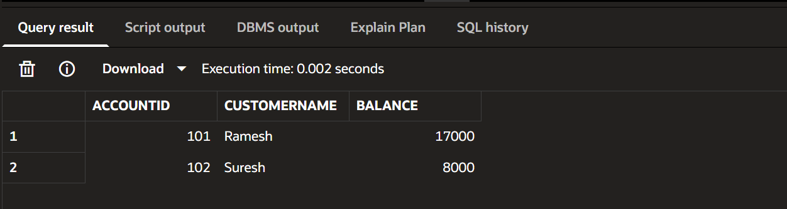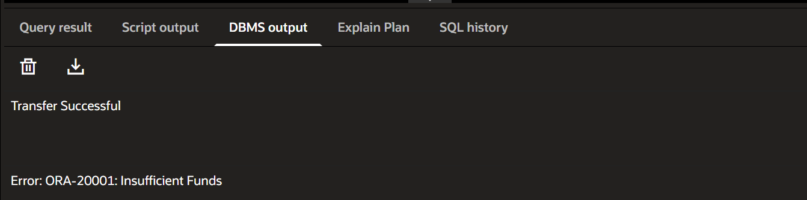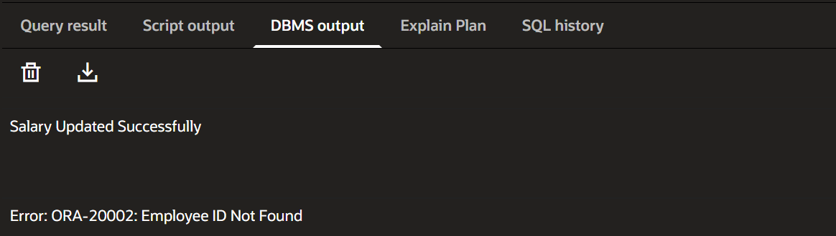

EXERCISE-3
STORED PROCEDURES

CREATE TABLE Accounts (
AccountID NUMBER PRIMARY KEY,
AccountType VARCHAR2(20),
Balance NUMBER
);

CREATE TABLE Employees (
EmployeeID NUMBER PRIMARY KEY,
EmployeeName VARCHAR2(50),
Department VARCHAR2(50),
Salary NUMBER
);
INSERT INTO Accounts VALUES (101,'Savings',10000);
INSERT INTO Accounts VALUES (102,'Savings',20000);
INSERT INTO Accounts VALUES (103,'Current',15000);

INSERT INTO Employees VALUES (1,'Anil','IT',40000);
INSERT INTO Employees VALUES (2,'Sunita','IT',50000);
INSERT INTO Employees VALUES (3,'Rahul','HR',35000);

COMMIT;
SELECT * FROM Accounts;

SELECT * FROM Employees;
CREATE OR REPLACE PROCEDURE ProcessMonthlyInterest
IS
BEGIN

UPDATE Accounts
SET Balance = Balance + (Balance * 0.01)
WHERE AccountType = 'Savings';

COMMIT;

DBMS_OUTPUT.PUT_LINE(
'Monthly Interest Applied'
);

END;
/
BEGIN
ProcessMonthlyInterest;
END;
/
CREATE OR REPLACE PROCEDURE UpdateEmployeeBonus(
p_Department VARCHAR2,
p_BonusPercent NUMBER
)
IS
BEGIN

UPDATE Employees
SET Salary =
Salary +
(Salary * p_BonusPercent/100)
WHERE Department = p_Department;

COMMIT;

DBMS_OUTPUT.PUT_LINE(
'Bonus Updated Successfully'
);

END;
/
BEGIN
UpdateEmployeeBonus('IT',10);
END;
/
CREATE OR REPLACE PROCEDURE TransferFunds(
p_FromAccount NUMBER,
p_ToAccount NUMBER,
p_Amount NUMBER
)
IS
v_Balance NUMBER;
BEGIN

SELECT Balance
INTO v_Balance
FROM Accounts
WHERE AccountID = p_FromAccount;

IF v_Balance < p_Amount THEN
DBMS_OUTPUT.PUT_LINE(
'Insufficient Balance'
);
RETURN;
END IF;

UPDATE Accounts
SET Balance = Balance - p_Amount
WHERE AccountID = p_FromAccount;

UPDATE Accounts
SET Balance = Balance + p_Amount
WHERE AccountID = p_ToAccount;

COMMIT;

DBMS_OUTPUT.PUT_LINE(
'Transfer Successful'
);

END;
/
BEGIN
TransferFunds(102,103,5000);
END;
/

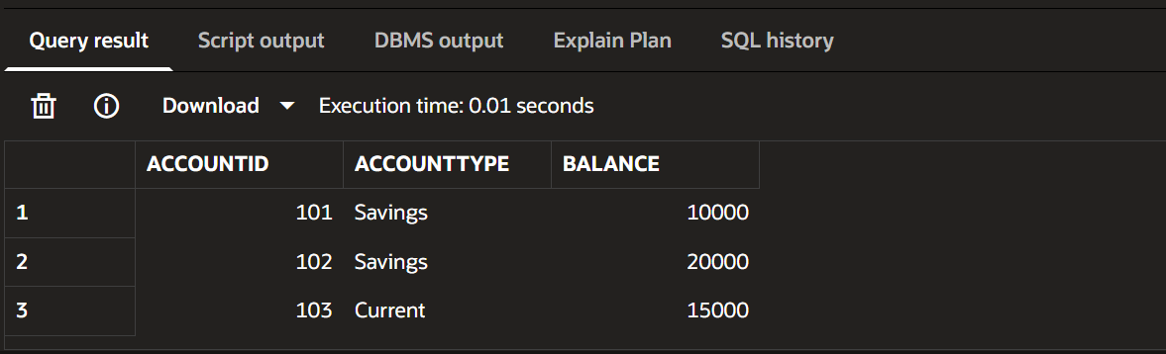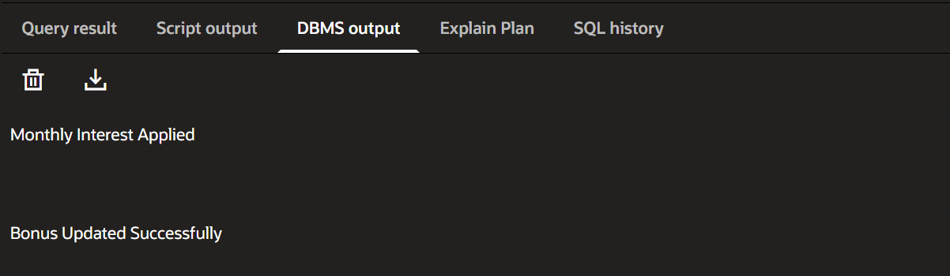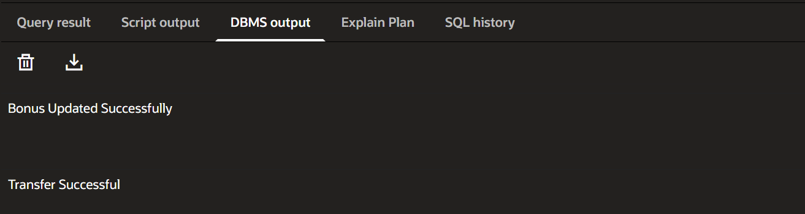

EXERCISE-4
FUNCTIONS
CREATE TABLE Customers (
CustomerID NUMBER PRIMARY KEY,
CustomerName VARCHAR2(50),
DateOfBirth DATE
);
CREATE TABLE Accounts (
AccountID NUMBER PRIMARY KEY,
CustomerName VARCHAR2(50),
Balance NUMBER
);
INSERT INTO Customers
VALUES (1,'Ramesh',TO_DATE('15-05-1990','DD-MM-YYYY'));
INSERT INTO Customers
VALUES (2,'Suresh',TO_DATE('20-08-1985','DD-MM-YYYY'));
INSERT INTO Accounts
VALUES (101,'Ramesh',15000);
INSERT INTO Accounts
VALUES (102,'Suresh',5000);
COMMIT;
CREATE OR REPLACE FUNCTION CalculateAge(
p_DOB DATE
)
RETURN NUMBER
IS
v_Age NUMBER;
BEGIN
v_Age := FLOOR(MONTHS_BETWEEN(SYSDATE,p_DOB)/12);
RETURN v_Age;
END;
/
SELECT CalculateAge(
TO_DATE('15-05-1990','DD-MM-YYYY')
) AS AGE
FROM DUAL;
CREATE OR REPLACE FUNCTION CalculateMonthlyInstallment(
p_LoanAmount NUMBER,
p_InterestRate NUMBER,
p_Years NUMBER
)
RETURN NUMBER
IS
v_Installment NUMBER;
BEGIN
v_Installment :=
(p_LoanAmount +
(p_LoanAmount * p_InterestRate/100 * p_Years))
/
(p_Years * 12);
RETURN ROUND(v_Installment,2);
END;
/
SELECT CalculateMonthlyInstallment(
100000,
10,
5
) AS EMI
FROM DUAL;
CREATE OR REPLACE FUNCTION HasSufficientBalance(
p_AccountID NUMBER,
p_Amount NUMBER
)
RETURN VARCHAR2
IS
v_Balance NUMBER;
BEGIN

SELECT Balance
INTO v_Balance
FROM Accounts
WHERE AccountID = p_AccountID;

IF v_Balance >= p_Amount THEN
RETURN 'TRUE';
ELSE
RETURN 'FALSE';
END IF;

EXCEPTION
WHEN NO_DATA_FOUND THEN
RETURN 'ACCOUNT NOT FOUND';
END;
/
SELECT HasSufficientBalance(
101,
10000
) AS STATUS
FROM DUAL;
SELECT HasSufficientBalance(
999,
1000
) AS STATUS
FROM DUAL;
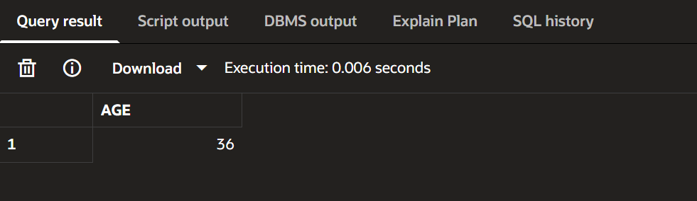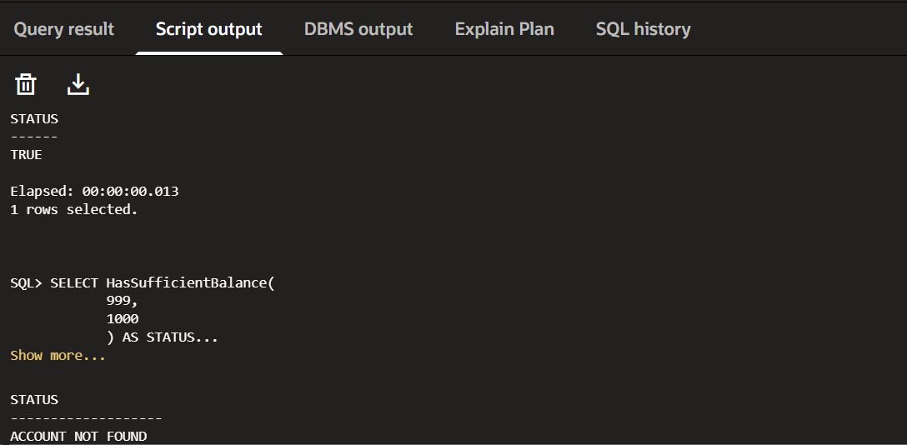

Exercise 5
Triggers
CREATE TABLE Customers (
CustomerID NUMBER PRIMARY KEY,
CustomerName VARCHAR2(50),
Balance NUMBER,
LastModified DATE
);
CREATE TABLE Transactions (
TransactionID NUMBER PRIMARY KEY,
AccountID NUMBER,
TransactionType VARCHAR2(20),
Amount NUMBER
);
CREATE TABLE AuditLog (
LogID NUMBER PRIMARY KEY,
TransactionID NUMBER,
LogDate DATE,
Action VARCHAR2(100)
);
INSERT INTO Customers
VALUES (1,'Ramesh',15000,SYSDATE);
INSERT INTO Customers
VALUES (2,'Suresh',5000,SYSDATE);
COMMIT;
CREATE OR REPLACE TRIGGER UpdateCustomerLastModified
BEFORE UPDATE
ON Customers
FOR EACH ROW
BEGIN
:NEW.LastModified := SYSDATE;
END;
/
SELECT * FROM Customers;
UPDATE Customers
SET Balance = 20000
WHERE CustomerID = 1;
COMMIT;
SELECT * FROM Customers;
CREATE OR REPLACE TRIGGER LogTransaction
AFTER INSERT
ON Transactions
FOR EACH ROW
DECLARE
v_LogID NUMBER;
BEGIN
SELECT NVL(MAX(LogID),0)+1
INTO v_LogID
FROM AuditLog;
INSERT INTO AuditLog
VALUES (
v_LogID,
:NEW.TransactionID,
SYSDATE,
'Transaction Inserted'
);

END;
/
INSERT INTO Transactions
VALUES (101,1,'Deposit',5000);
COMMIT;
SELECT * FROM AuditLog;
CREATE OR REPLACE TRIGGER CheckTransactionRules
BEFORE INSERT
ON Transactions
FOR EACH ROW
DECLARE
v_Balance NUMBER;
BEGIN
IF :NEW.TransactionType = 'Deposit' THEN
IF :NEW.Amount <= 0 THEN
RAISE_APPLICATION_ERROR(
-20001,
'Deposit amount must be positive'
);
END IF;
ELSIF :NEW.TransactionType = 'Withdrawal' THEN
SELECT Balance
INTO v_Balance
FROM Customers
WHERE CustomerID = :NEW.AccountID;
IF :NEW.Amount > v_Balance THEN
RAISE_APPLICATION_ERROR(
-20002,
'Insufficient Balance'
);
END IF;
END IF;
END;
/
INSERT INTO Transactions
VALUES (102,1,'Deposit',1000);
COMMIT;
INSERT INTO Transactions
VALUES (103,1,'Deposit',-500);
INSERT INTO Transactions
VALUES (104,1,'Withdrawal',5000);
COMMIT;
INSERT INTO Transactions
VALUES (105,2,'Withdrawal',50000);
SELECT * FROM Customers;
SELECT * FROM Transactions;
SELECT * FROM AuditLog;

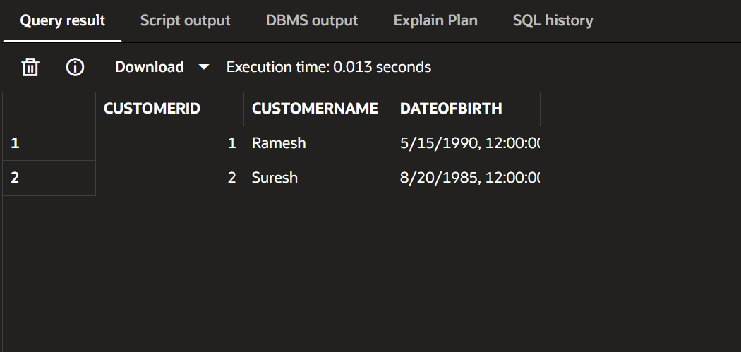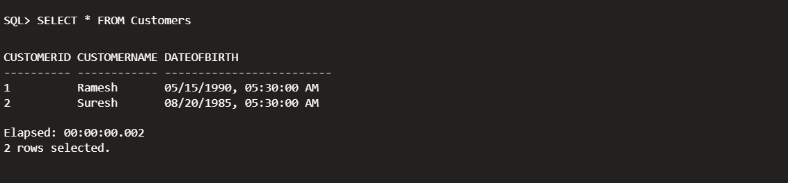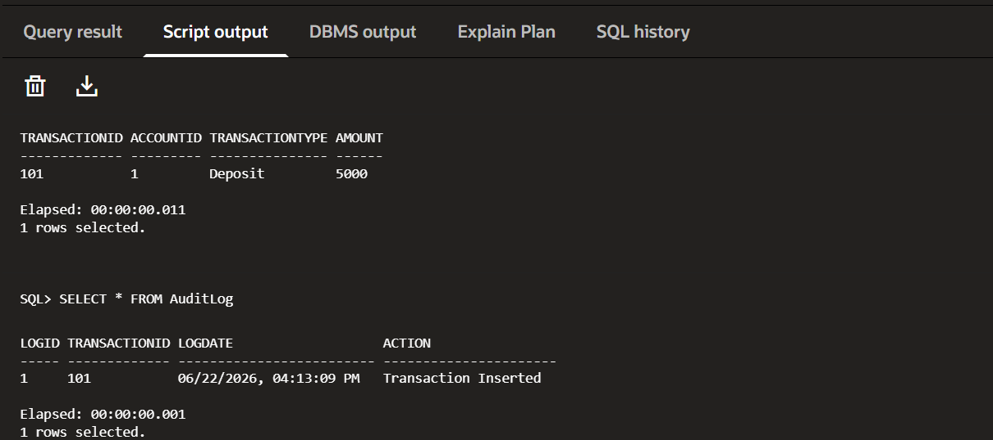

Exercise 6
Cursors
CREATE TABLE Accounts (
AccountID NUMBER PRIMARY KEY,
CustomerName VARCHAR2(50),
Balance NUMBER
);
CREATE TABLE Transactions (
TransactionID NUMBER PRIMARY KEY,
AccountID NUMBER,
TransactionDate DATE,
Amount NUMBER
);
CREATE TABLE Loans (
LoanID NUMBER PRIMARY KEY,
CustomerName VARCHAR2(50),
InterestRate NUMBER
);
INSERT INTO Accounts VALUES (101,'Ramesh',15000);
INSERT INTO Accounts VALUES (102,'Suresh',12000);
INSERT INTO Accounts VALUES (103,'Anita',18000);
INSERT INTO Transactions
VALUES (1,101,SYSDATE-5,2000);
INSERT INTO Transactions
VALUES (2,101,SYSDATE-2,1500);
INSERT INTO Transactions
VALUES (3,102,SYSDATE-10,3000);

INSERT INTO Transactions
VALUES (4,103,SYSDATE-15,4000);
INSERT INTO Loans
VALUES (201,'Ramesh',10);
INSERT INTO Loans
VALUES (202,'Suresh',11);
INSERT INTO Loans
VALUES (203,'Anita',12);
COMMIT;
SET SERVEROUTPUT ON;
DECLARE
CURSOR GenerateMonthlyStatements IS
SELECT AccountID,
TransactionID,
Amount,
TransactionDate
FROM Transactions
WHERE TRUNC(TransactionDate,'MM')
= TRUNC(SYSDATE,'MM');
v_AccountID Transactions.AccountID%TYPE;
v_TransactionID Transactions.TransactionID%TYPE;
v_Amount Transactions.Amount%TYPE;
v_Date Transactions.TransactionDate%TYPE;
BEGIN
OPEN GenerateMonthlyStatements;
LOOP
FETCH GenerateMonthlyStatements
INTO v_AccountID,
v_TransactionID,
v_Amount,
v_Date;
EXIT WHEN GenerateMonthlyStatements%NOTFOUND;
DBMS_OUTPUT.PUT_LINE(
'Account: ' || v_AccountID ||
' Transaction: ' || v_TransactionID ||
' Amount: ' || v_Amount ||
' Date: ' || TO_CHAR(v_Date,'DD-MON-YYYY')
);
END LOOP;
CLOSE GenerateMonthlyStatements;
END;
/
DECLARE
CURSOR ApplyAnnualFee IS
SELECT AccountID
FROM Accounts;
v_AccountID Accounts.AccountID%TYPE;
BEGIN
OPEN ApplyAnnualFee;
LOOP
FETCH ApplyAnnualFee
INTO v_AccountID;
EXIT WHEN ApplyAnnualFee%NOTFOUND;
UPDATE Accounts
SET Balance = Balance - 500
WHERE AccountID = v_AccountID;
END LOOP;
CLOSE ApplyAnnualFee;
COMMIT;
DBMS_OUTPUT.PUT_LINE(
'Annual Fee Applied Successfully'
);
END;
/
SELECT * FROM Accounts;
DECLARE
CURSOR UpdateLoanInterestRates IS
SELECT LoanID
FROM Loans;
v_LoanID Loans.LoanID%TYPE;
BEGIN
OPEN UpdateLoanInterestRates;
LOOP
FETCH UpdateLoanInterestRates
INTO v_LoanID;
EXIT WHEN UpdateLoanInterestRates%NOTFOUND;
UPDATE Loans
SET InterestRate = InterestRate - 0.5
WHERE LoanID = v_LoanID;
END LOOP;
CLOSE UpdateLoanInterestRates;
COMMIT;
DBMS_OUTPUT.PUT_LINE(
'Interest Rates Updated Successfully'
);
END;
/ SELECT * FROM Loans;
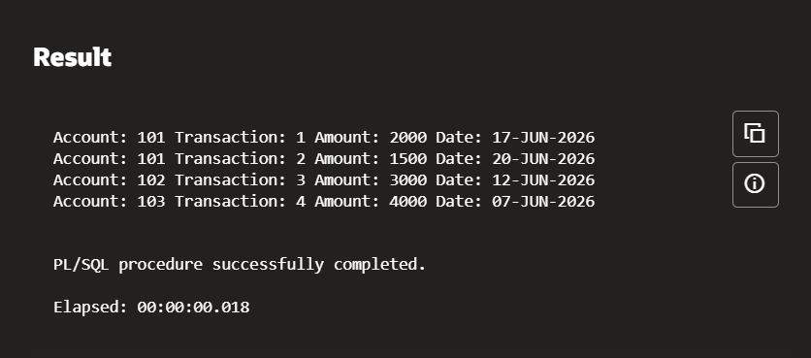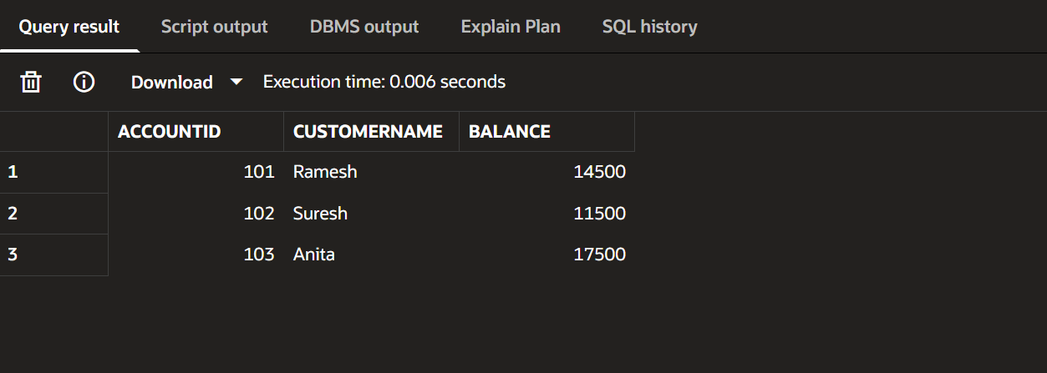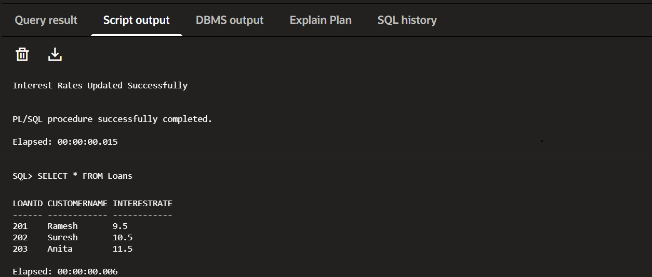

EXERCISE-7
PACKAGES

CREATE TABLE Customers (
CustomerID NUMBER PRIMARY KEY,
Name VARCHAR2(100),
DOB DATE,
Balance NUMBER,
LastModified DATE
);

CREATE TABLE Accounts (
AccountID NUMBER PRIMARY KEY,
CustomerID NUMBER,
AccountType VARCHAR2(20),
Balance NUMBER,
LastModified DATE,
FOREIGN KEY (CustomerID) REFERENCES Customers(CustomerID)
);

CREATE TABLE Transactions (
TransactionID NUMBER PRIMARY KEY,
AccountID NUMBER,
TransactionDate DATE,
Amount NUMBER,
TransactionType VARCHAR2(10),
FOREIGN KEY (AccountID) REFERENCES Accounts(AccountID)
);

CREATE TABLE Loans (
LoanID NUMBER PRIMARY KEY,
CustomerID NUMBER,
LoanAmount NUMBER,
InterestRate NUMBER,
StartDate DATE,
EndDate DATE,
FOREIGN KEY (CustomerID) REFERENCES Customers(CustomerID)
);

CREATE TABLE Employees (
EmployeeID NUMBER PRIMARY KEY,
Name VARCHAR2(100),
Position VARCHAR2(50),
Salary NUMBER,
Department VARCHAR2(50),
HireDate DATE
);
INSERT INTO Customers VALUES
(1,'John Doe',TO_DATE('1985-05-15','YYYY-MM-DD'),1000,SYSDATE);

INSERT INTO Customers VALUES
(2,'Jane Smith',TO_DATE('1990-07-20','YYYY-MM-DD'),1500,SYSDATE);

INSERT INTO Accounts VALUES
(1,1,'Savings',1000,SYSDATE);

INSERT INTO Accounts VALUES
(2,2,'Checking',1500,SYSDATE);

INSERT INTO Transactions VALUES
(1,1,SYSDATE,200,'Deposit');

INSERT INTO Transactions VALUES
(2,2,SYSDATE,300,'Withdrawal');

INSERT INTO Loans VALUES
(1,1,5000,5,SYSDATE,ADD_MONTHS(SYSDATE,60));

INSERT INTO Employees VALUES
(1,'Alice Johnson','Manager',70000,'HR',
TO_DATE('2015-06-15','YYYY-MM-DD'));

INSERT INTO Employees VALUES
(2,'Bob Brown','Developer',60000,'IT',
TO_DATE('2017-03-20','YYYY-MM-DD'));

COMMIT;
CREATE OR REPLACE PACKAGE CustomerManagement AS

PROCEDURE AddCustomer(
p_CustomerID NUMBER,
p_Name VARCHAR2,
p_DOB DATE,
p_Balance NUMBER
);

PROCEDURE UpdateCustomer(
p_CustomerID NUMBER,
p_Name VARCHAR2
);

FUNCTION GetCustomerBalance(
p_CustomerID NUMBER
) RETURN NUMBER;

END CustomerManagement;
/
CREATE OR REPLACE PACKAGE BODY CustomerManagement AS

PROCEDURE AddCustomer(
p_CustomerID NUMBER,
p_Name VARCHAR2,
p_DOB DATE,
p_Balance NUMBER
)
IS
BEGIN
INSERT INTO Customers
VALUES(
p_CustomerID,
p_Name,
p_DOB,
p_Balance,
SYSDATE
);
END;

PROCEDURE UpdateCustomer(
p_CustomerID NUMBER,
p_Name VARCHAR2
)
IS
BEGIN
UPDATE Customers
SET Name = p_Name,
LastModified = SYSDATE
WHERE CustomerID = p_CustomerID;
END;

FUNCTION GetCustomerBalance(
p_CustomerID NUMBER
)
RETURN NUMBER
IS
v_Balance NUMBER;
BEGIN
SELECT Balance
INTO v_Balance
FROM Customers
WHERE CustomerID = p_CustomerID;

RETURN v_Balance;
END;

END CustomerManagement;
/
BEGIN
CustomerManagement.AddCustomer(
3,
'Satwik',
TO_DATE('2004-01-01','YYYY-MM-DD'),
2000
);
END;
/
BEGIN
CustomerManagement.UpdateCustomer(
3,
'Satwik Reddy'
);
END;
/
SELECT CustomerManagement.GetCustomerBalance(3)
AS Balance
FROM DUAL;
CREATE OR REPLACE PACKAGE EmployeeManagement AS

PROCEDURE HireEmployee(
p_ID NUMBER,
p_Name VARCHAR2,
p_Position VARCHAR2,
p_Salary NUMBER,
p_Department VARCHAR2
);

PROCEDURE UpdateEmployee(
p_ID NUMBER,
p_Salary NUMBER
);

FUNCTION CalculateAnnualSalary(
p_ID NUMBER
) RETURN NUMBER;

END EmployeeManagement;
/
CREATE OR REPLACE PACKAGE BODY EmployeeManagement AS

PROCEDURE HireEmployee(
p_ID NUMBER,
p_Name VARCHAR2,
p_Position VARCHAR2,
p_Salary NUMBER,
p_Department VARCHAR2
)
IS
BEGIN
INSERT INTO Employees
VALUES(
p_ID,
p_Name,
p_Position,
p_Salary,
p_Department,
SYSDATE
);
END;

PROCEDURE UpdateEmployee(
p_ID NUMBER,
p_Salary NUMBER
)
IS
BEGIN
UPDATE Employees
SET Salary = p_Salary
WHERE EmployeeID = p_ID;
END;

FUNCTION CalculateAnnualSalary(
p_ID NUMBER
)
RETURN NUMBER
IS
v_Salary NUMBER;
BEGIN
SELECT Salary
INTO v_Salary
FROM Employees
WHERE EmployeeID = p_ID;

RETURN v_Salary * 12;
END;

END EmployeeManagement;
/
BEGIN
EmployeeManagement.HireEmployee(
3,
'Rahul',
'Tester',
50000,
'QA'
);
END;
/
BEGIN
EmployeeManagement.UpdateEmployee(
3,
55000
);
END;
/
SELECT EmployeeManagement.CalculateAnnualSalary(3)
AS AnnualSalary
FROM DUAL;
CREATE OR REPLACE PACKAGE AccountOperations AS

PROCEDURE OpenAccount(
p_AccountID NUMBER,
p_CustomerID NUMBER,
p_Type VARCHAR2,
p_Balance NUMBER
);

PROCEDURE CloseAccount(
p_AccountID NUMBER
);

FUNCTION GetTotalBalance(
p_CustomerID NUMBER
) RETURN NUMBER;

END AccountOperations;
/
CREATE OR REPLACE PACKAGE BODY AccountOperations AS

PROCEDURE OpenAccount(
p_AccountID NUMBER,
p_CustomerID NUMBER,
p_Type VARCHAR2,
p_Balance NUMBER
)
IS
BEGIN
INSERT INTO Accounts
VALUES(
p_AccountID,
p_CustomerID,
p_Type,
p_Balance,
SYSDATE
);
END;

PROCEDURE CloseAccount(
p_AccountID NUMBER
)
IS
BEGIN
DELETE FROM Accounts
WHERE AccountID = p_AccountID;
END;

FUNCTION GetTotalBalance(
p_CustomerID NUMBER
)
RETURN NUMBER
IS
v_Total NUMBER;
BEGIN
SELECT SUM(Balance)
INTO v_Total
FROM Accounts
WHERE CustomerID = p_CustomerID;

RETURN NVL(v_Total,0);
END;

END AccountOperations;
/
BEGIN
AccountOperations.OpenAccount(
3,
1,
'Savings',
5000
);
END;
/
SELECT AccountOperations.GetTotalBalance(1)
AS TotalBalance
FROM DUAL;
BEGIN
AccountOperations.CloseAccount(3);
END;
/
SELECT * FROM Customers;

SELECT * FROM Employees;

SELECT * FROM Accounts;
